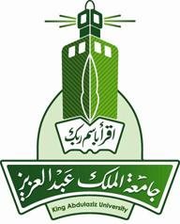

Proposed model for light of the development of administrative performance in the Department of Girls’ Education in Al Rass in an introduction to knowledge management

by:Fatimah saleh alaoufi

Athesis submitted for the requirements for getting master degree in( educational administration)

supervised By:

Dr. Ensaf Mohamed Badr

educational diploma program
king abd al aziz university
jeddah_ kingdom of saudi arabia
6/Rajab/ 1432H – 3/May 2011G

